CLERK’S THIRD QUARTER 2018 REPORT

Period: 06/01/2018 through 08/31/2018
Membership Summary
Total Membership as of 05/31/2018 (end of 2Q) ………………………………………... 233
New and Re-Instated Members (in 3Q) (2 Youth) + 11
Members Removed (Inactivity, Moved, Death) (in 3Q) ………………………………… - 7
Database Anomalies (Negative) - 6
Total Membership as of 08/31/2018 …………………………………………………… 231
JOINED and REINSTATED
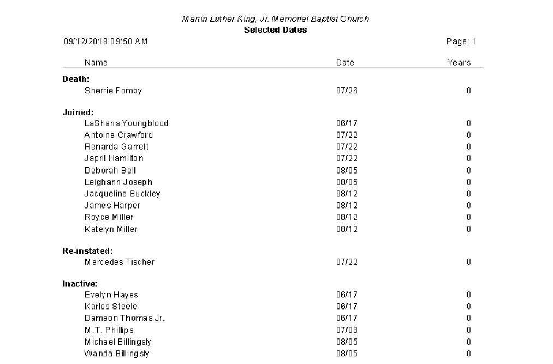

Humbly Submitted,
Carla Bunn, Church Clerk

